**Individual report**

Mashenjun 4420977

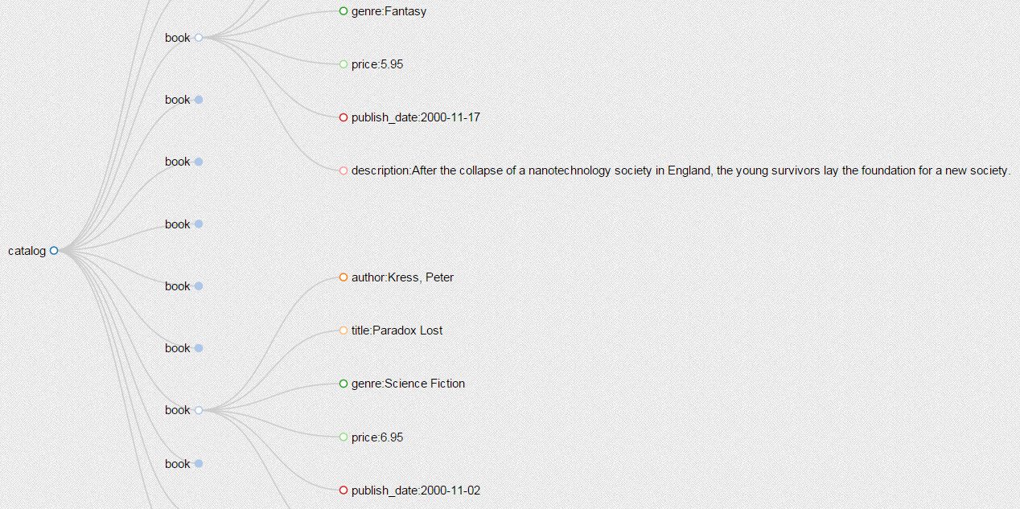In the final report, I mainly focus on the visualization of node structure and relationship of node and attribute. I choose tree layout to visualize the nodes structure. Tree layout performs well when showing the inheritance relationship which is extremely suitable for visualizing XML file. From the visualization result, user can clearly see the parent nodes, children nodes and the inheritance relationship. Note that I hide all the attribute value in this vision in order to make the graphic natty. The result is shown in figure 1.

Figure 1

At the leave node, we add text value on the graph and remove all attribute value. We also use expand, collapse and brushing operation to enhance the interactive. These interactions can be done by click on the node or drag the mouse. Besides, I also use categorical color to distinguish different nodes and tooltip to show simple attribute value. Just as shown in figure2, figure 3.

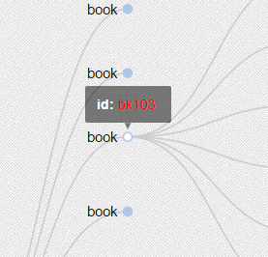 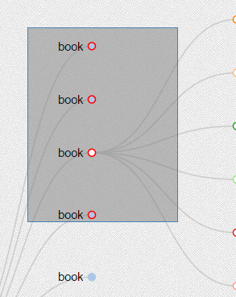

Figure 2 Figure 3

However, users are still interesting in the attribute value. So I also want to do visualization about the nodes and corresponding attribute value. This time I use force layout to show the attributes and the relationship between attribute and nodes. Form the structure graphic, user can derive a new graphic by choosing nodes they are interested in and clicking the show attribute button. Then a new force shows up as the figure 4.

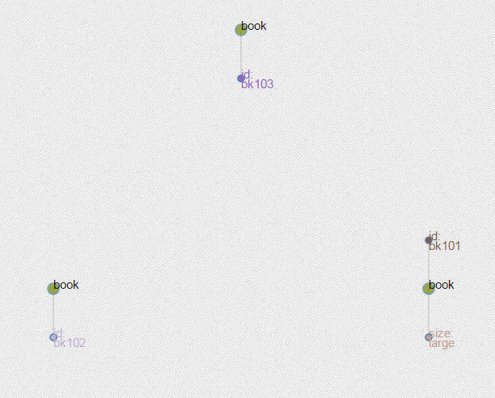

Figure 4

Clicking the button again user can back to the structure graphic. Force layout can clearly show the relationship of the attribute and node. Categorical colors are also used to distinguish different attributes. Thus user can have a more general view about the attributes. Note that I make the code general which can visualize all XML file.

The links are two examples:

<http://mashenjun.github.io/DataVis/XMLViewbook>

<http://mashenjun.github.io/DataVis/XMLViewcomplex>

codes: ---XMLViewbook.html

---XMLViewcomplex.html